☁️ AZURE CLOUD ACCOUNT CREATION

- Below is the current process for creating a Microsoft Azure Free Account.
- Microsoft currently offers eligible new customers USD $200 credit for the first 30 days, plus selected free services for 12 months and 65+ always-free services.

- Requirements
- Before starting, keep these ready:
- 📧 Microsoft account
- 📱 Mobile phone number
- 💳 Credit/debit card for identity verification
- 🏠 Address details
- 🌐 Internet browser such as Chrome or Edge

- Microsoft states that a non-prepaid credit/debit card and phone number are required for verification for the standard free account.

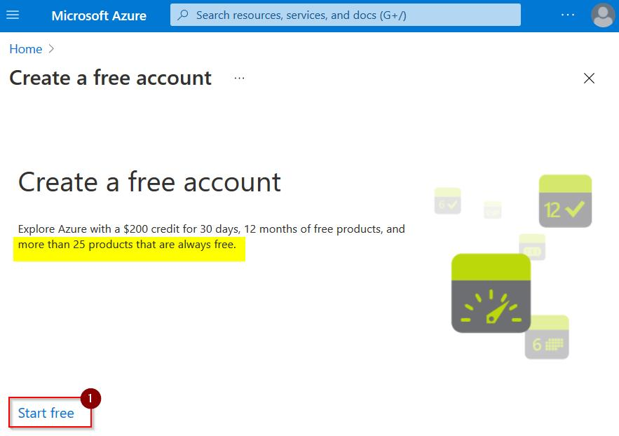

- Step 1: Go to the Azure Website
- URL: https://azure.microsoft.com/en-us/free/

  - What you'll see:

┌──────────────────────────────────────────────────┐
│ │
│ Create Your Azure Free Account │
│ │
│ Start with $200 Azure credit │
│ + 12 months of popular free services │
│ + 55+ always-free services │
│ │
│ ┌──────────────────────────┐ │
│ │ Start free → │ │
│ └──────────────────────────┘ │
│ │
└──────────────────────────────────────────────────┘

- Step 2: Sign In or Create a Microsoft Account

┌──────────────────────────────────────────────────┐
│ │
│ Microsoft Sign In │
│ │
│ ┌──────────────────────────────────┐ │
│ │ Email, phone, or Skype │ │
│ └──────────────────────────────────┘ │
│ │
│ ┌────────────┐ │
│ │ Next → │ │
│ └────────────┘ │
│ │
│ No account? Create one! │
│ │
└──────────────────────────────────────────────────┘

- If you have an existing Microsoft account : Enter your email and click "Next"
- If you DON'T have a Microsoft account : Click "Create one!"

- Step 2a: Creating a New Microsoft Account (if needed)

┌──────────────────────────────────────────────────┐
│ │
│ Create account │
│ │
│ ┌──────────────────────────────────┐ │
│ │ someone@example.com │ │
│ └──────────────────────────────────┘ │
│ │
│ Or get a new email address │
│ │
│ ┌────────────┐ │
│ │ Next → │ │
│ └────────────┘ │
│ │
└──────────────────────────────────────────────────┘

- ✅ Enter your email address → Click "Next"
- Create Password :

┌──────────────────────────────────────────────────┐
│ │
│ Create a password │
│ │
│ ┌──────────────────────────────────┐ │
│ │ •••••••• │ │
│ └──────────────────────────────────┘ │
│ │
│ ┌────────────┐ │
│ │ Next → │ │
│ └────────────┘ │
│ │
└──────────────────────────────────────────────────┘

- ✅ Create a strong password → Click "Next"

- Step 3: Email Verification

┌──────────────────────────────────────────────────┐
│ │
│ Verify your email │
│ │
│ We've sent a code to someone@example.com │
│ │
│ ┌──────────────────────────────────┐ │
│ │ Enter code: _ _ _ _ │ │
│ └──────────────────────────────────┘ │
│ │
│ ┌────────────┐ │
│ │ Verify → │ │
│ └────────────┘ │
│ │
└──────────────────────────────────────────────────┘

- ✅ Check your email for the verification code → Enter it → Click "Verify"

- Step 4: CAPTCHA Verification

┌──────────────────────────────────────────────────┐
│ │
│ Solve the puzzle to prove you're human │
│ │
│ ┌──────────────────────────────────┐ │
│ │ │ │
│ │ [CAPTCHA Challenge Image] │ │
│ │ │ │
│ └──────────────────────────────────┘ │
│ │
│ ┌────────────┐ │
│ │ Next → │ │
│ └────────────┘ │
│ │
└──────────────────────────────────────────────────┘

- ✅ Complete the CAPTCHA challenge → Click "Next"

- Step 5: Azure Sign-Up Form - Your Profile

┌──────────────────────────────────────────────────────────┐
│ │
│ Sign up - About you │
│ │
│ ┌─── 1. About you ──── 2. Identity ──── 3. Agreement ─┐│
│ │ (active) (pending) (pending) ││
│ └──────────────────────────────────────────────────────┘│
│ │
│ Country/Region: ┌──────────────────────┐ │
│ │ Select country ▼ │ │
│ └──────────────────────┘ │
│ │
│ First Name: ┌──────────────────────┐ │
│ │ │ │
│ └──────────────────────┘ │
│ │
│ Last Name: ┌──────────────────────┐ │
│ │ │ │
│ └──────────────────────┘ │
│ │
│ Email: ┌──────────────────────┐ │
│ │ (pre-filled) │ │
│ └──────────────────────┘ │
│ │
│ Phone: ┌──────────────────────┐ │
│ │ +1 ___-___-____ │ │
│ └──────────────────────┘ │
│ │
│ ┌────────────┐ │
│ │ Next → │ │
│ └────────────┘ │
│ │
└──────────────────────────────────────────────────────────┘

- Fill in all the fields :
- Select your Country/Region
- Enter First Name & Last Name
- Verify Email address
- Enter Phone number
- Click "Next"

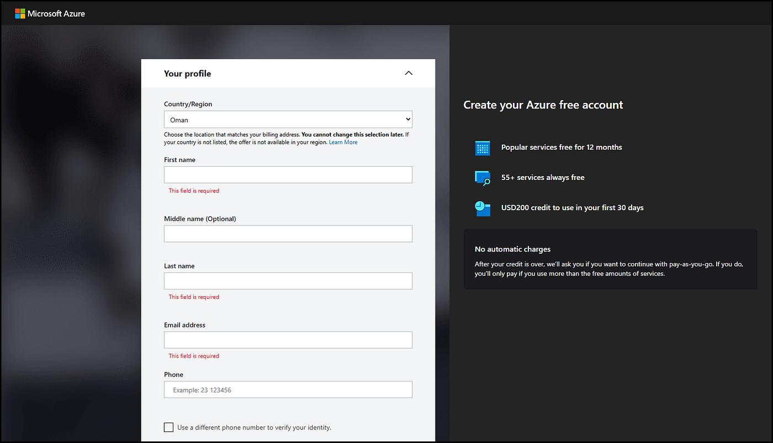

- Step 6: Identity Verification by Phone

┌──────────────────────────────────────────────────┐
│ │
│ Identity verification by phone │
│ │
│ ┌──────────────────────────────────┐ │
│ │ Phone number: +1 ___________ │ │
│ └──────────────────────────────────┘ │
│ │
│ ○ Text me │
│ ○ Call me │
│ │
│ ┌──────────────────────────────────┐ │
│ │ Verification code: ______ │ │
│ └──────────────────────────────────┘ │
│ │
│ ┌─────────────────┐ │
│ │ Verify code → │ │
│ └─────────────────┘ │
│ │
└──────────────────────────────────────────────────┘

- Actions:
  - Enter your phone number
  - Choose "Text me" or "Call me"
- Enter the verification code received
- Click "Verify code"

- Step 7: Identity Verification by Card

┌──────────────────────────────────────────────────────────┐
│ │
│ Identity verification by card │
│ (You won't be charged unless you upgrade) │
│ │
│ Card Number: ┌──────────────────────────┐ │
│ │ ____ ____ ____ ____ │ │
│ └──────────────────────────┘ │
│ │
│ Expiry Date: ┌────────┐ ┌────────┐ │
│ │ MM │ │ YY │ │
│ └────────┘ └────────┘ │
│ │
│ CVV: ┌────────┐ │
│ │ ___ │ │
│ └────────┘ │
│ │
│ Name on Card: ┌──────────────────────────┐ │
│ │ │ │
│ └──────────────────────────┘ │
│ │
│ Address Line 1: ┌──────────────────────────┐ │
│ │ │ │
│ └──────────────────────────┘ │
│ │
│ City: ┌──────────────────────────┐ │
│ │ │ │
│ └──────────────────────────┘ │
│ │
│ State: ┌──────────────────────────┐ │
│ │ Select state ▼ │ │
│ └──────────────────────────┘ │
│ │
│ Zip Code: ┌──────────────────────────┐ │
│ │ │ │
│ └──────────────────────────┘ │
│ │
└──────────────────────────────────────────────────────────┘

- Enter your credit/debit card details
- ⚠️ Note: A temporary $1 hold may appear for verification. You will NOT be charged for the free account.

- Step 8: Agreement

┌──────────────────────────────────────────────────────────┐
│ │
│ Agreement │
│ │
│ ☑ I agree to the subscription agreement, │
│ offer details, and privacy statement │
│ │
│ ☐ I would like information, tips, and offers │
│ about Azure and other Microsoft products │
│ │
│ │
│ ┌──────────────────────┐ │
│ │ Sign up → │ │
│ └──────────────────────┘ │
│ │
└──────────────────────────────────────────────────────────┘

- Actions :
- Check the agreement checkbox (required)
- Optionally check marketing emails
- Click "Sign up"

- Step 9: Setting Up Your Account (Loading)

┌──────────────────────────────────────────────────┐
│ │
│ │
│ ⏳ Setting up your account... │
│ │
│ This may take a minute or two │
│ │
│ ████████░░░░░ 65% │
│ │
│ │
└──────────────────────────────────────────────────┘

- ⏳ Wait for Azure to provision your account (1-2 minutes)

- Step 10: Welcome to Azure! 🎉

┌──────────────────────────────────────────────────────────────┐
│ │
│ 🎉 You're ready to go with Azure! │
│ │
│ Your $200 credit is active for 30 days │
│ │
│ ┌───────────────────────────┐ │
│ │ Go to the Azure Portal → │ │
│ └───────────────────────────┘ │
│ │
└──────────────────────────────────────────────────────────────┘

- Click "Go to the Azure Portal"

- Step 11 : Login to Azure
- Provide username :
  - Click next
- Provide password
  - Click on yes for sign in

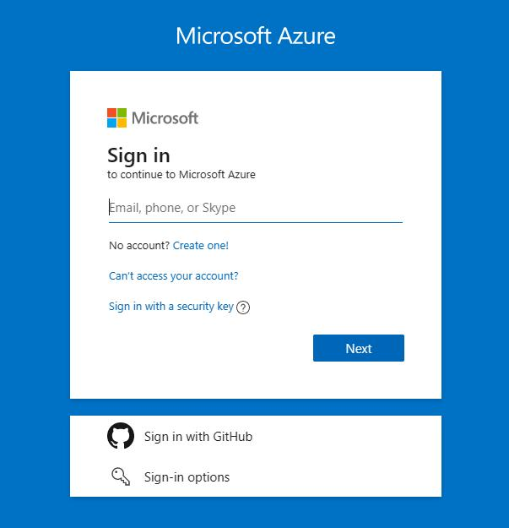

- Step 11 : Azure Portal Dashboard

🌐 URL: https://portal.azure.com

┌──────────────────────────────────────────────────────────────────────┐
│ ☰ Microsoft Azure 🔍 Search resources 🔔 ⚙️ 👤 │
├──────────────────────────────────────────────────────────────────────┤
│ │
│ Welcome to Microsoft Azure │
│ │
│ ┌─────────────┐ ┌─────────────┐ ┌─────────────┐ │
│ │ + Create │ │ 📚 Learn │ │ 📊 Monitor │ │
│ │ a resource │ │ │ │ │ │
│ └─────────────┘ └─────────────┘ └─────────────┘ │
│ │
│ Azure services │
│ ┌────────┐ ┌────────┐ ┌────────┐ ┌────────┐ ┌────────┐ │
│ │ Virtual│ │ App │ │ SQL │ │Storage │ │ More │ │
│ │Machines│ │Services│ │Database│ │Accounts│ │Services│ │
│ └────────┘ └────────┘ └────────┘ └────────┘ └────────┘ │
│ │
│ Recent resources │
│ ┌──────────────────────────────────────────────────────┐ │
│ │ No recent resources │ │
│ └──────────────────────────────────────────────────────┘ │
│ │
│ Navigate │
│ • Subscriptions • Resource groups │
│ • All resources • Dashboard │
│ • Marketplace • Cost Management │
│ │
└──────────────────────────────────────────────────────────────────────┘

🎉 Congratulations! Your Azure account is now ready to use!

- Azure Free Account Benefits :
- $200 credit Valid for 30 days
- 12-month free Popular services including services : 750 hrs B1S Windows/Linux VM, 250 GB SQL Database, 5 GB Blob Storage, 5 GB File Storage, 1M Cosmos DB requests
♾️ Always free → 55+ services including : Azure Functions (1M requests), Azure DevOps (5 users), App Service (10 web apps), Azure Kubernetes Service

⚠️ Important Tips

Tip | Details
💳 No surprise charges | Free tier won't auto-charge; you must manually upgrade
⏰ $200 credit expires | Use within 30 days or it's lost
📊 Monitor spending | Go to Cost Management + Billing regularly
🔒 Enable MFA | Set up Multi-Factor Authentication for security
🗑️ Delete unused resources | Stop/delete VMs and services when not in use
🔄 After 30 days | You'll be asked to upgrade to Pay-As-You-Go

- VIRTUAL MACHINE CREATION PROCESS

- In portal type Resource group
- Create a Resource Group
  - Name : any
  - Region : any
  - Click on “ Review and Create “

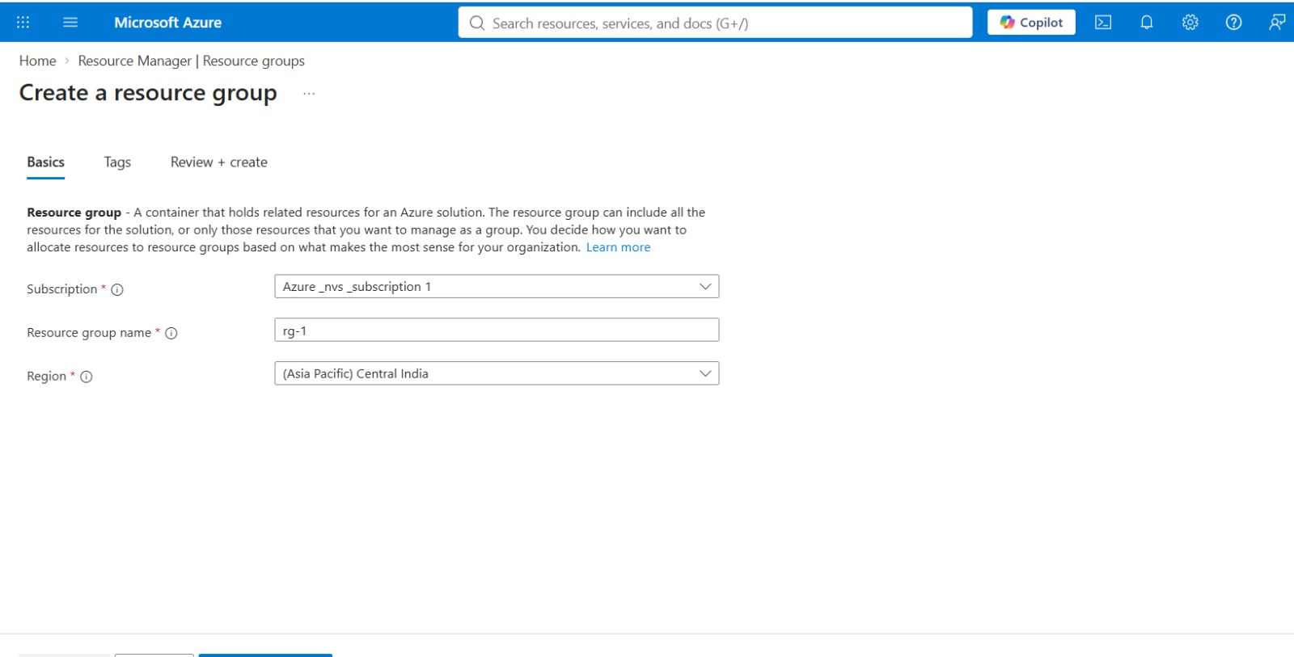

- After creation RG in portal

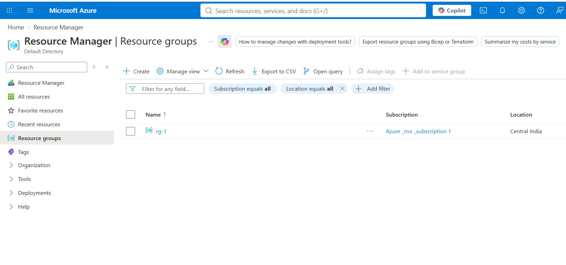
- Now resource group have been created.

- Create a Virtual Network
- In search bar type Vnet or Virtual Network
- Click on Create

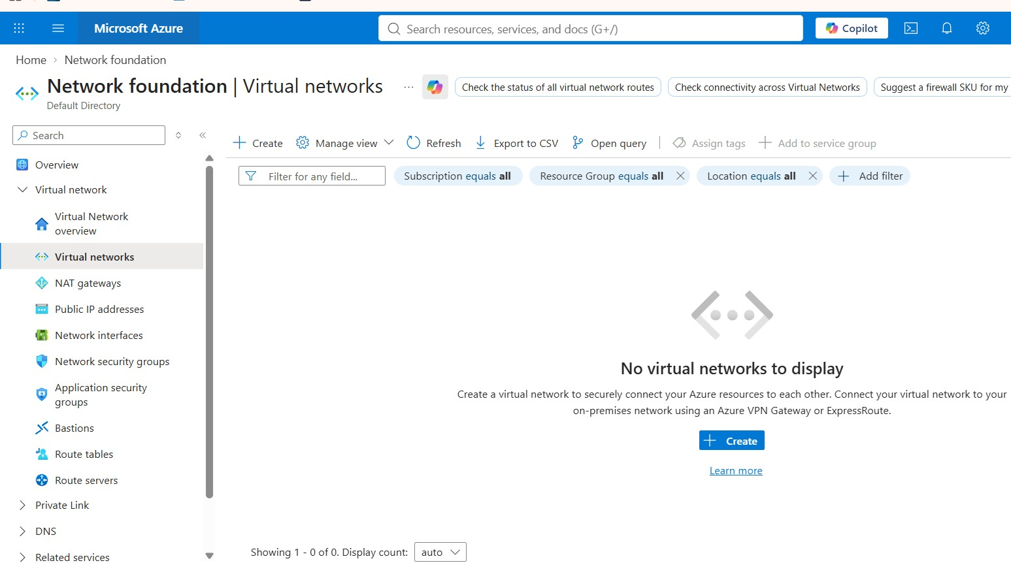

  - Select Resource group : which you have created
  - Name : any
  - Region : any

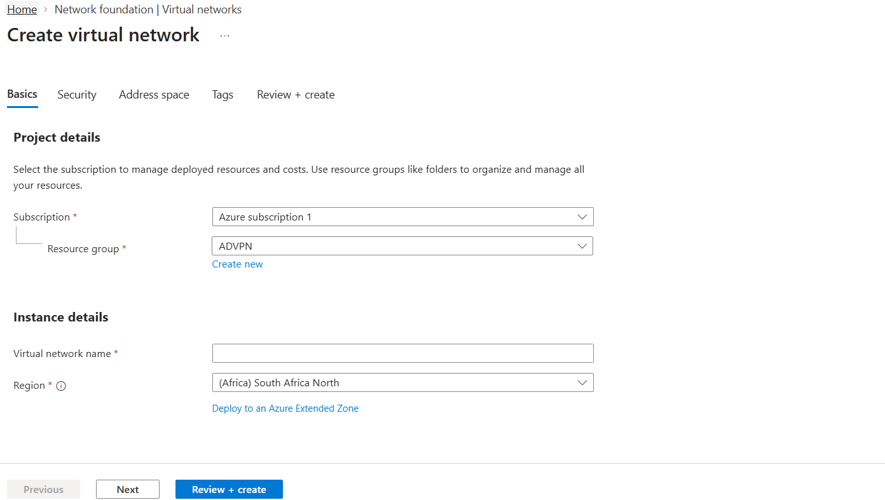

- Click on Address Space

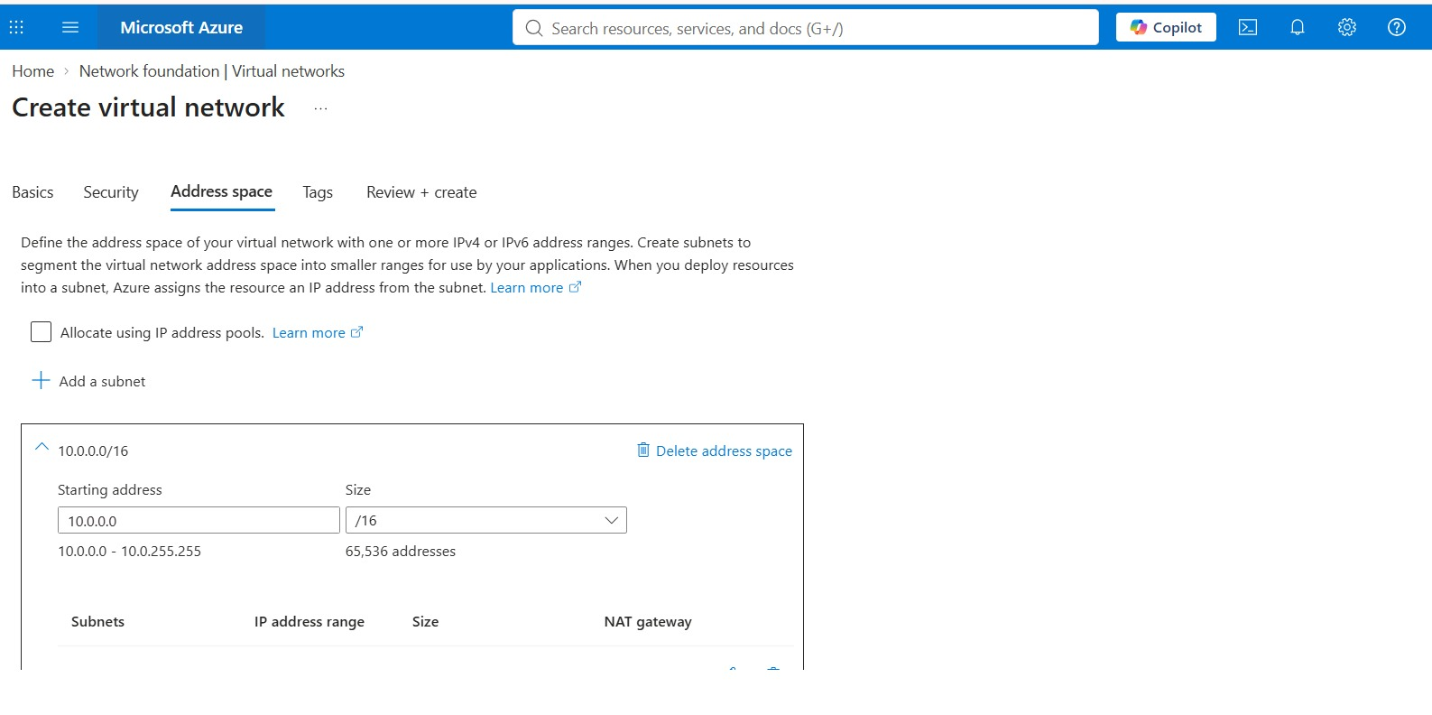
- Edit VNet IP address range to 10.0.0.0 and size /16
- For Vnet IP 2nd octet or 2nd number can be any thing from 1 to 255 )
- Click on Add new subnet,
  - Provide new name
  - Provide subnet address 1st 2 octets are same, and 3rd number can be changeable
  - Size is /24, /25

- Click on Review and create

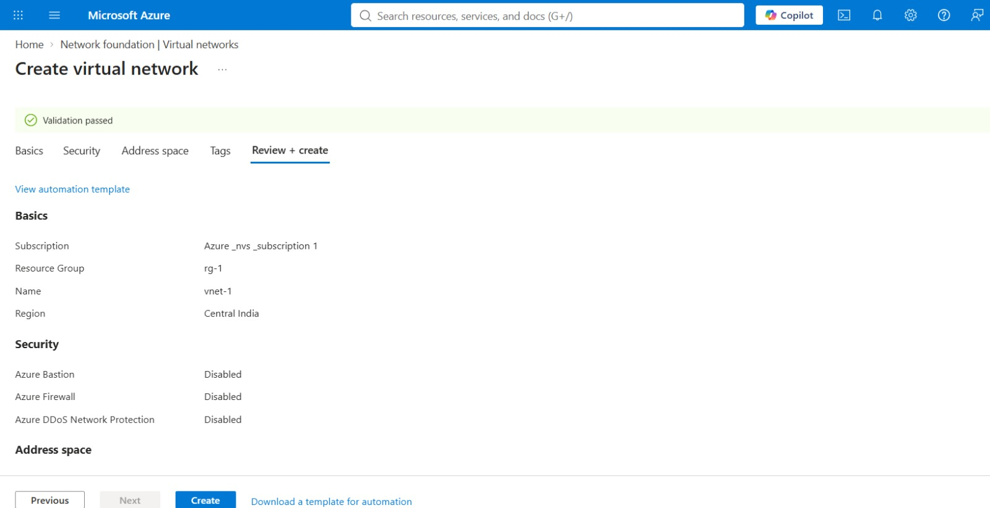

- Now click on Create

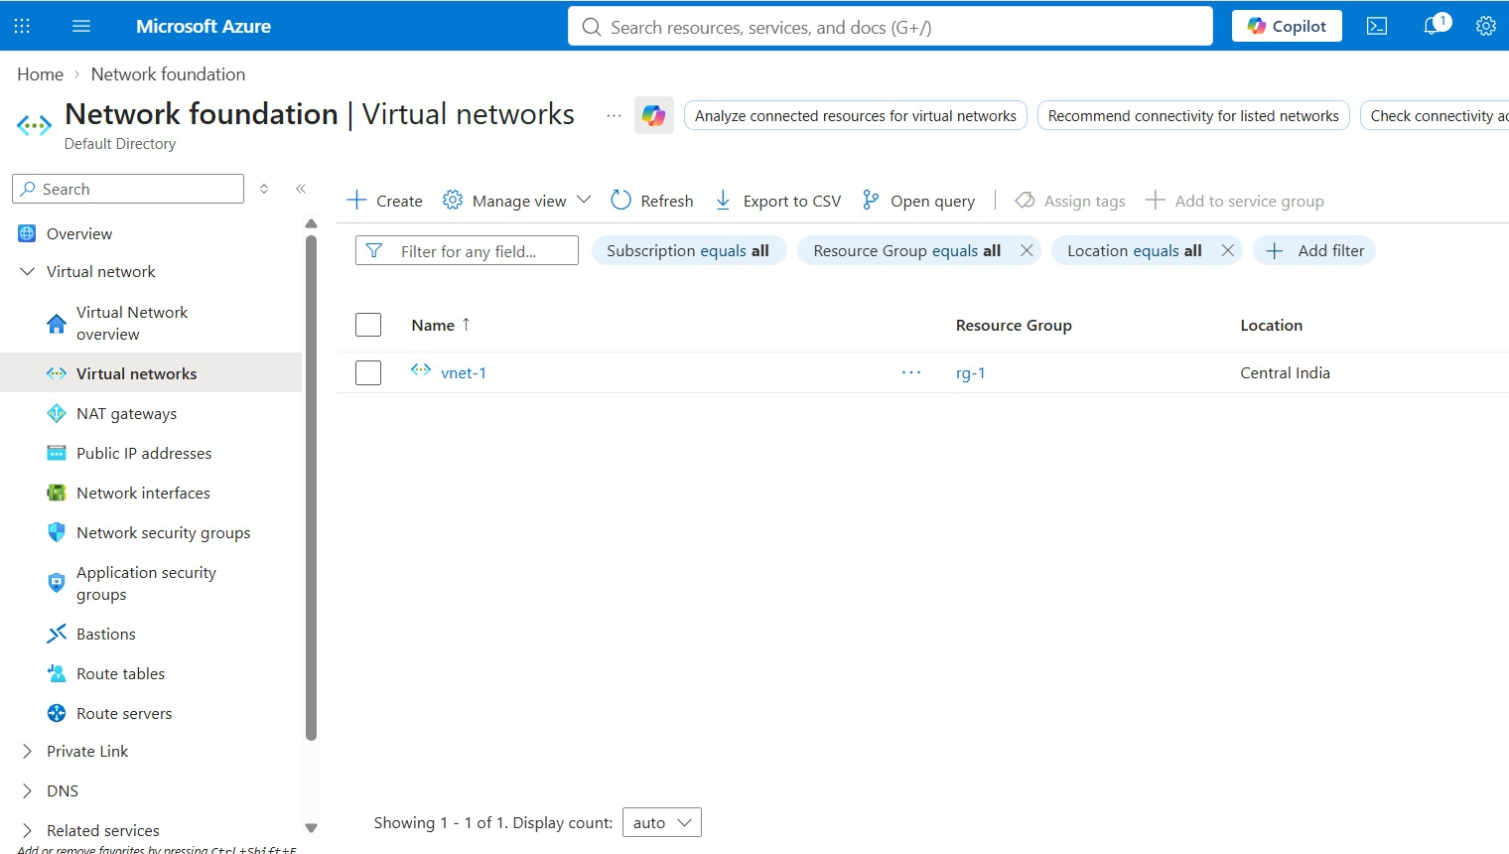

- Now virtual Network has been created.

- LINUX VIRTUAL MACHINE
- Now in search bar type Virtual machine and select it
- Now click on Create -> “ Virtual Machine “

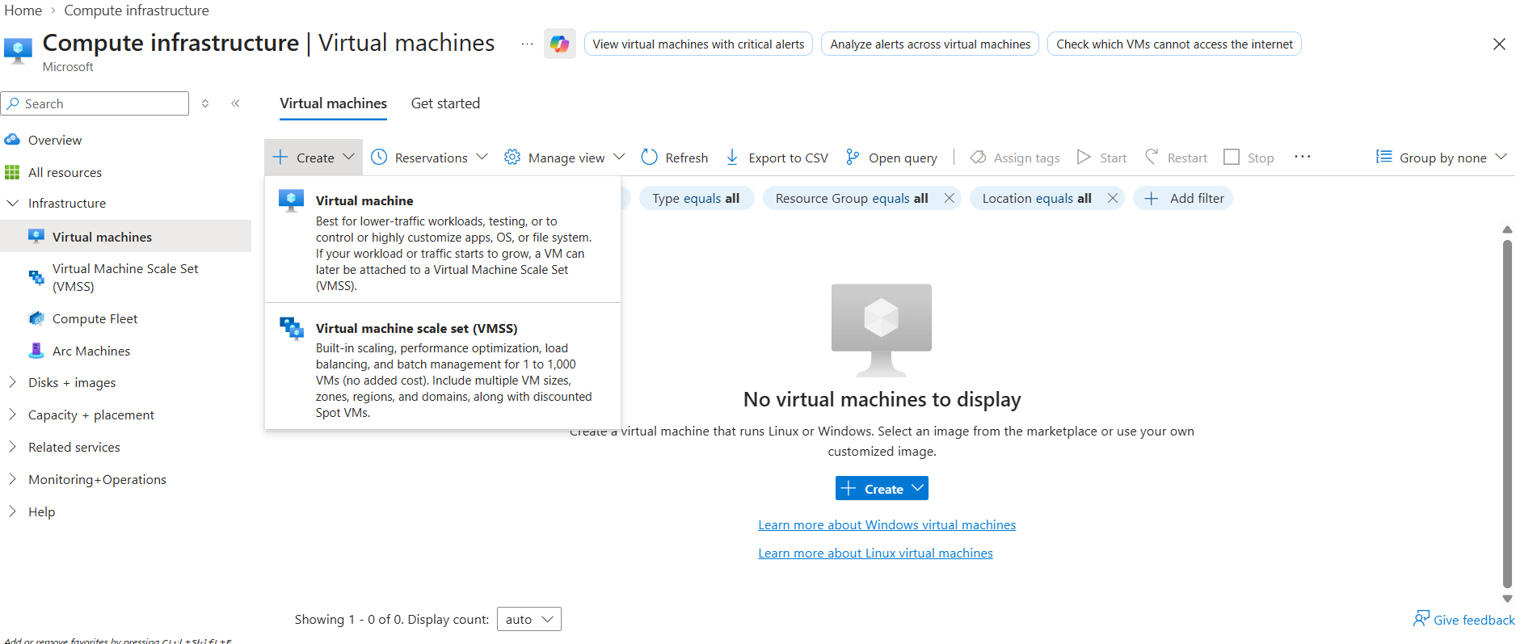

  - Subscription : select default one
  - Resource Group ( RG ): Select the RG which you have Created

  - Virtual Machine Name : any
  - Region : any ( Canada central, Japan East, Korea central, South Africa North )
    - These regions support virtual machine with 2 or 4GB RAM
  - Availability Option : No Infrastructure
  - Security Type : Standard
  - Image : any ubuntu or linux sever
  - VM Architecture : x64
  - Size : 1 or 2 or 4 or 8GB
  - Authentication Type : Password
  - Username : anything except username ( default will not be accepted )
  - Password : any thing
  - Confirm Password : reenter Password.
- Click on next to Disk section.

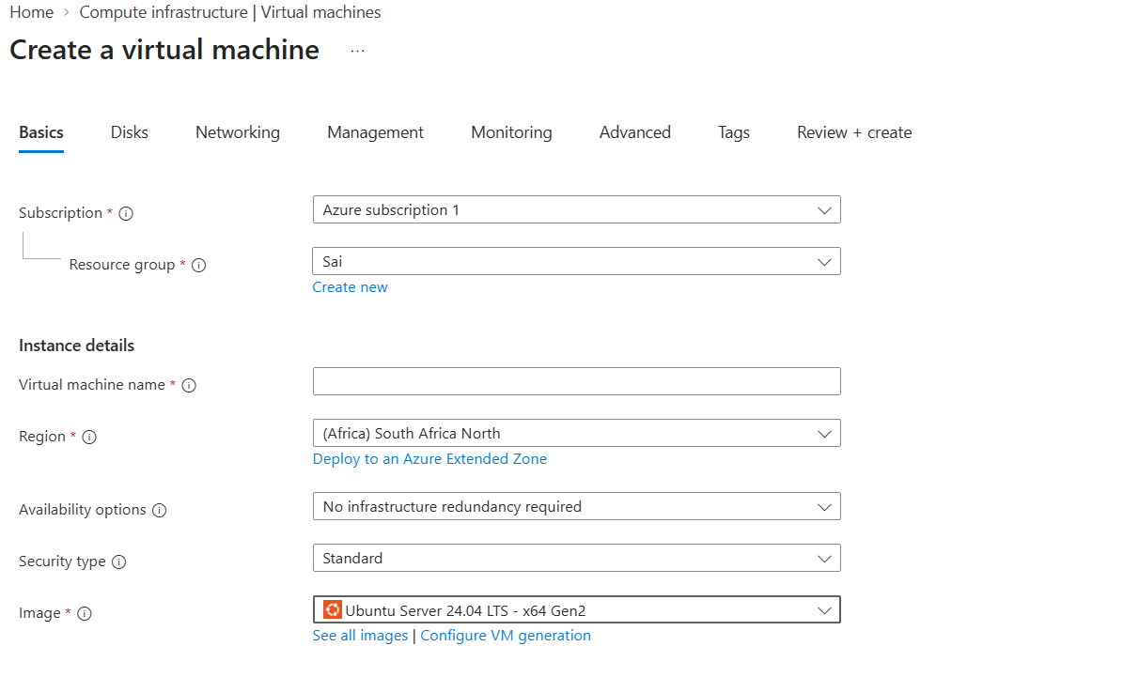
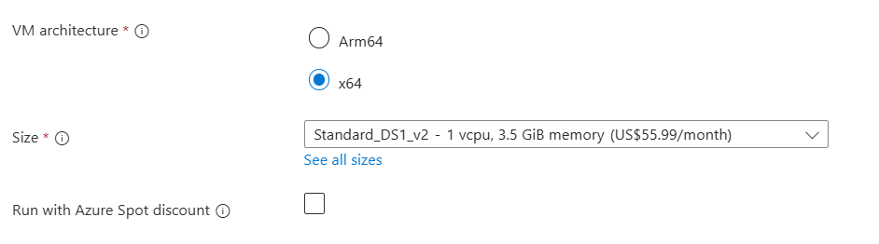
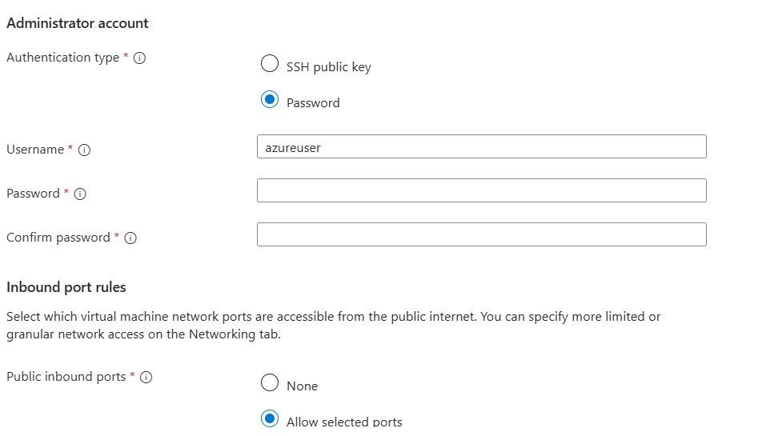

- OS Disk Size :
  - Disk Size : Default
  - Disk Type : change to Standard HDD
- Click on Next for Networking Section.

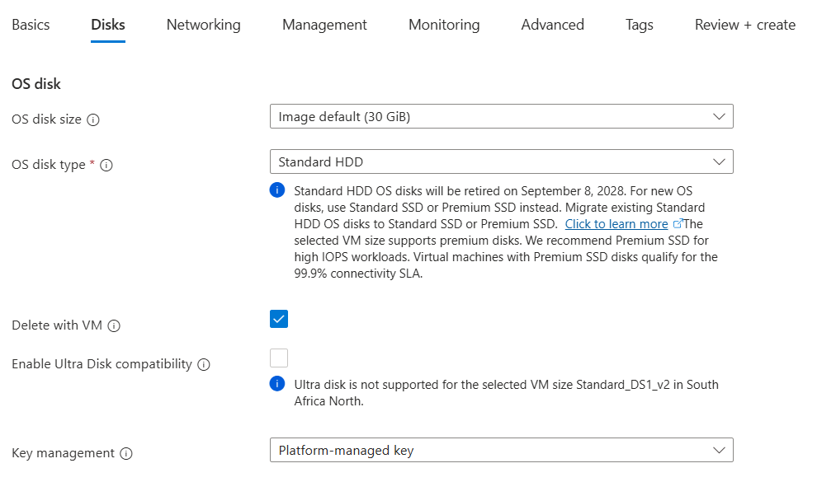

- Networking Section
  - Virtual Network : select your or create new
  - Subnet : select your or create new
  - Public IP : create new
  - NIC Network security Group : basic
  - Public inbound port : Allow selected ports
- Click review and create

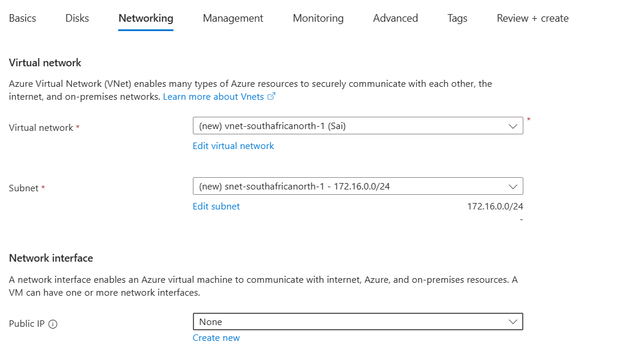
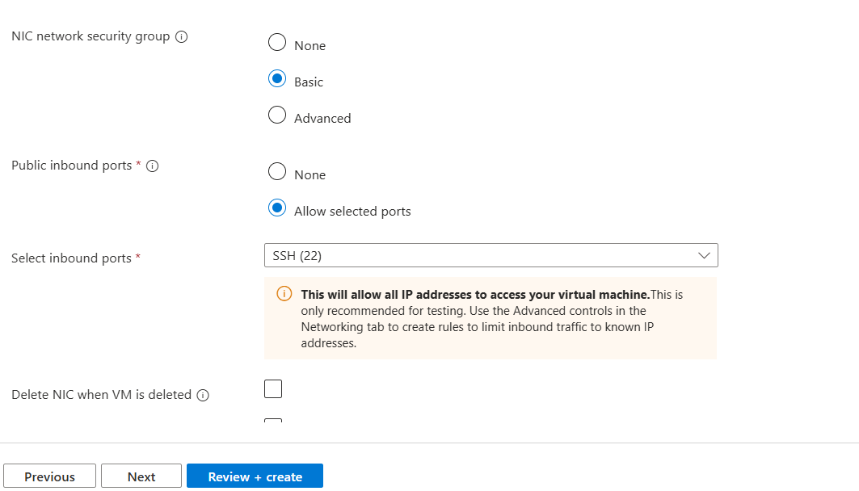

- Once validation is done

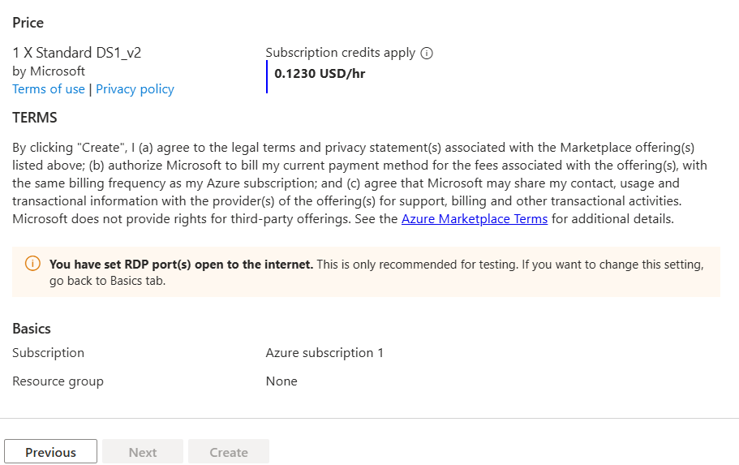

- Now click on create

- After virtual machine created click on go to resource.
- In Virtual Machine page right side you cal check public nic card number as public ip
- Open Moba Xterm
- Click on session
  - Click on SSH
    - Remote host : Public IP of Virtual Machine ( check in Virtual machine page right side )
    - Username : your username

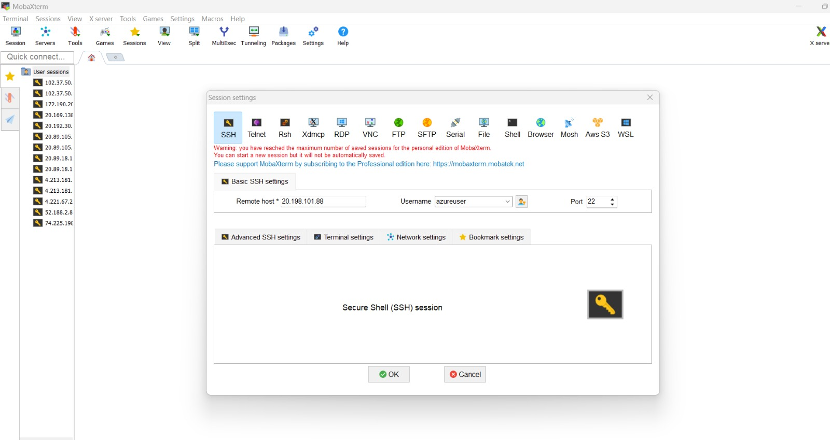

- Enter password : ( it will enter but not reflected i.e not visible )
- Click on OK

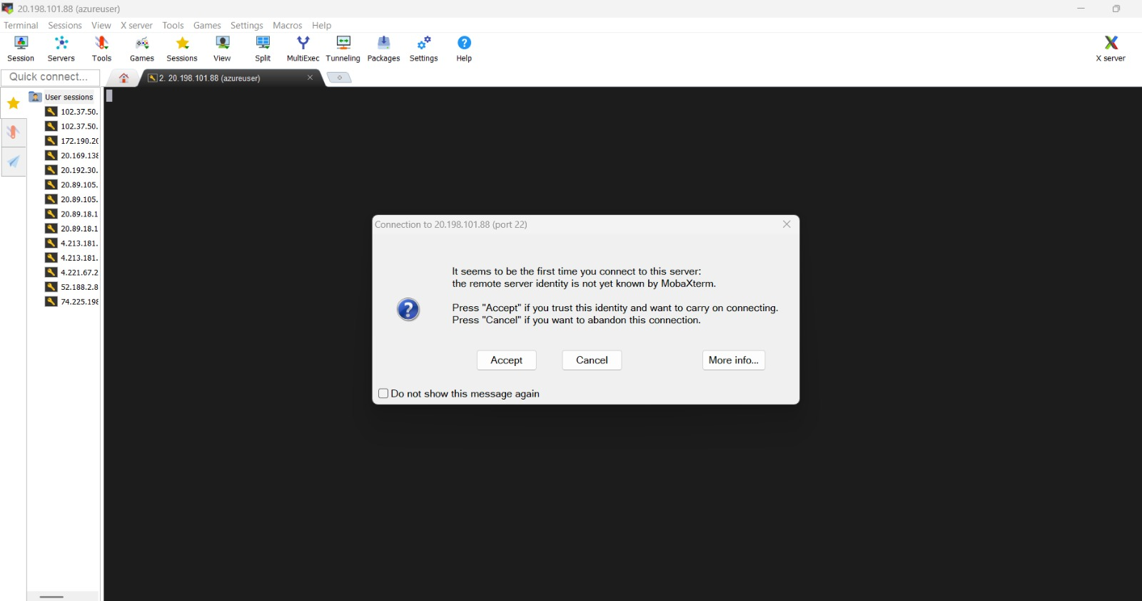

- Now click on Accept

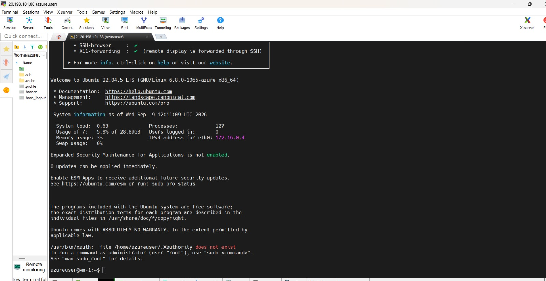

- Virtual machine creation is done and login also successfully done.

- WINDOWS VIRTUAL MACHINE
- Now in search bar type Virtual machine and select it
- Now click on Create -> “ Virtual Machine “

  - Subscription : select default one
  - Resource Group ( RG ): Select the RG which you have Created

  - Virtual Machine Name : any
  - Region : any ( Canada central, Japan East, Korea central, South Africa North )
    - These regions support virtual machine with 2 or 4GB RAM
  - Availability Option : No Infrastructure
  - Security Type : Standard
  - Image : any Windows sever
  - VM Architecture : x64
  - Size : 4 or 8GB
  - Authentication Type : Password
  - Username : anything except username ( default will not be accepted )
  - Password : any thing
  - Confirm Password : reenter Password.
- Click on next to Disk section.

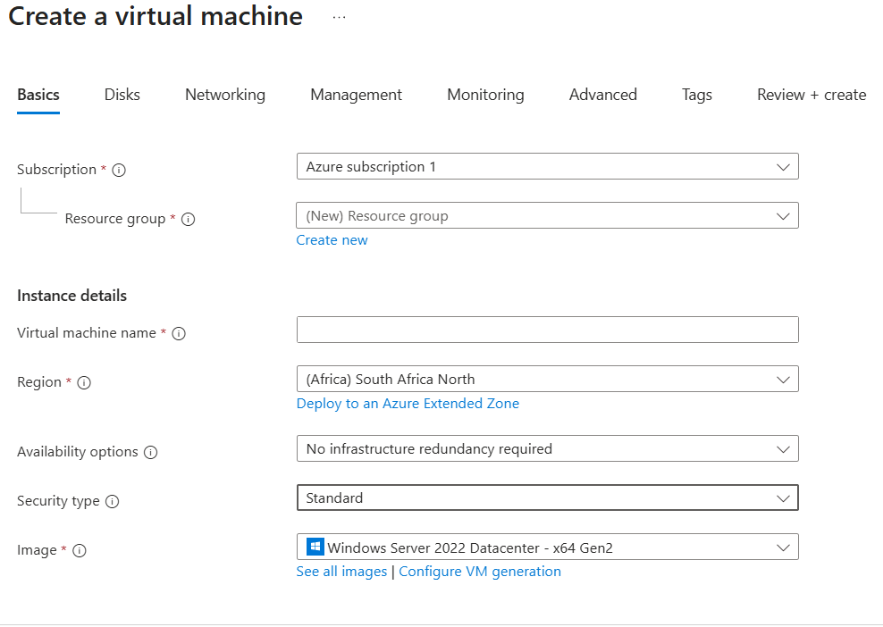

- OS Disk Size :
  - Disk Size : Default
  - Disk Type : change to Standard HDD
- Click on Next for Networking Section.

- Networking Section
  - Virtual Network : select your or create new
  - Subnet : select your or create new
  - Public IP : create new
  - NIC Network security Group : basic
  - Public inbound port : Allow selected ports
- Click review and create

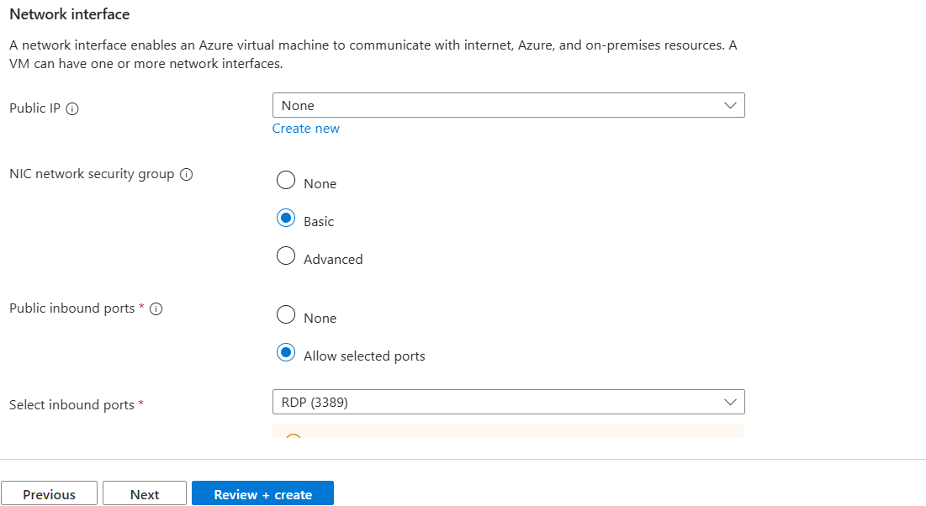

- Once validation is done

- Now click on create

- After virtual machine created click on go to resource.
- In Virtual Machine page right side you can check public nic card number as public ip

- Now Open MobaXterm or RDP

  - If Mobaxterm, Click session -> RDP
  - If RDP from window button
  - Enter ip address

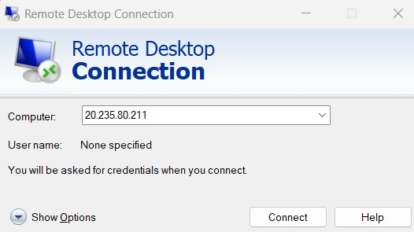

  - Username and password

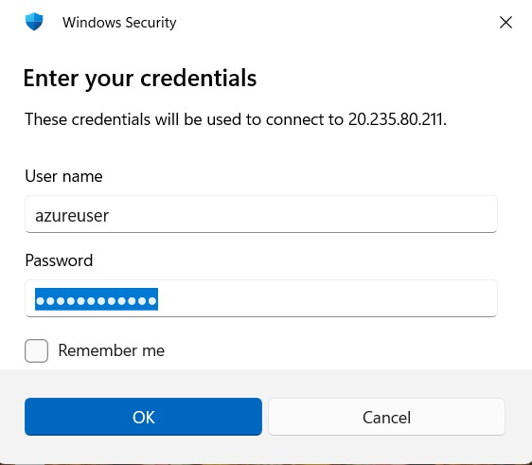

- Click on yes on certification page

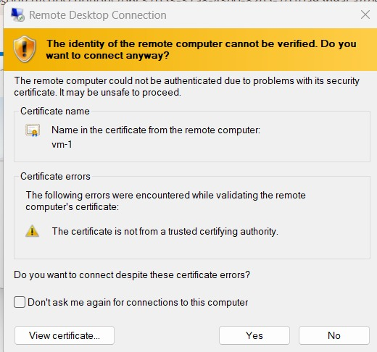

- Done

